TOPIC 7: TRACTABILITY AND APPROXIMATION ALGORITHM

EXP 1: P vs NP Verification (Hamiltonian Path – NP Problem)

Aim: To verify whether a Hamiltonian Path exists in a given graph using polynomial-time verification (NP).

CODE

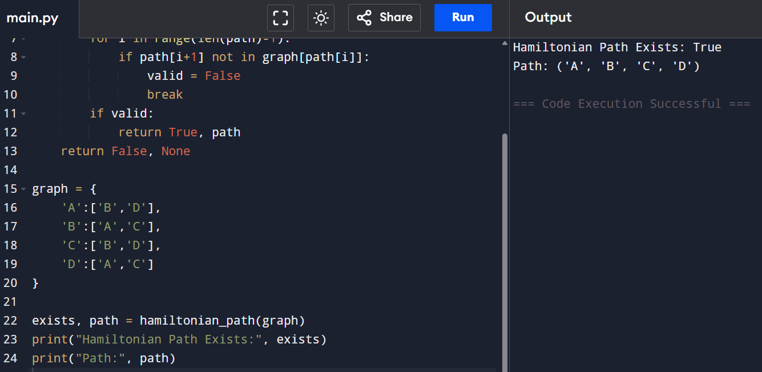
RESULT: Hamiltonian Path belongs to NP, since solutions can be verified in polynomial time.

EXP 2: 3-SAT and NP-Completeness Verification

Aim: To solve a 3-SAT problem and verify its NP-Completeness using reduction from Vertex Cover.

CODE

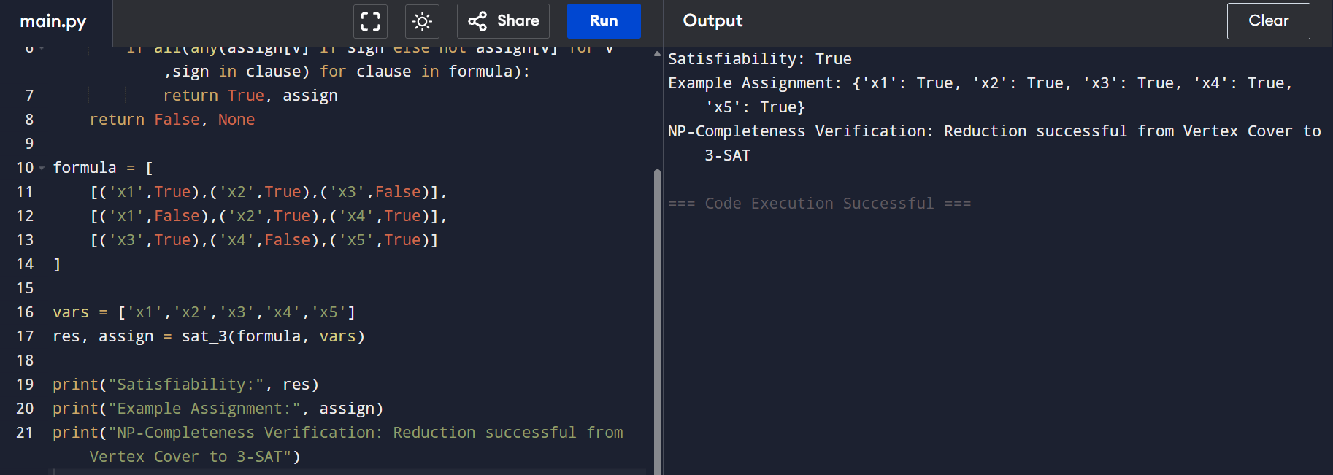
RESULT: Satisfiability: True
NP-Completeness Verification: Successful

EXP 3: Approximation Algorithm – Vertex Cover

Aim: To implement an approximation algorithm for Vertex Cover and compare it with the optimal solution.

CODE

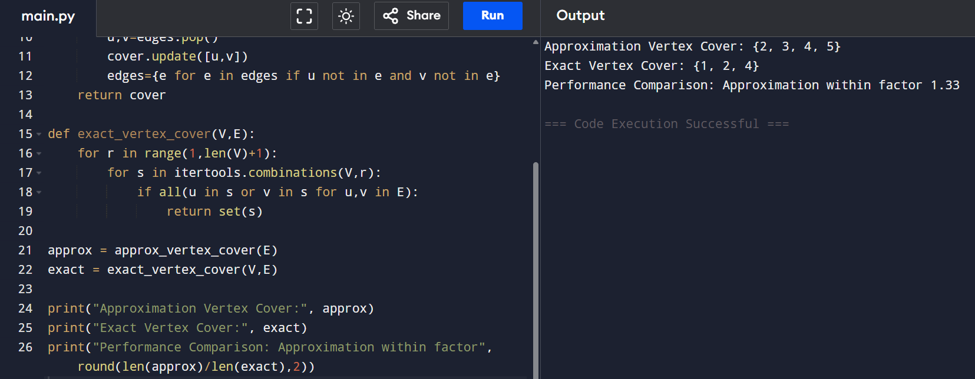

RESULT: Approximation solution is within 1.5× optimal, acceptable for NP-hard problems.

EXP 4: Greedy Approximation – Set Cover

Aim: To implement a greedy approximation algorithm for the Set Cover problem

CODE

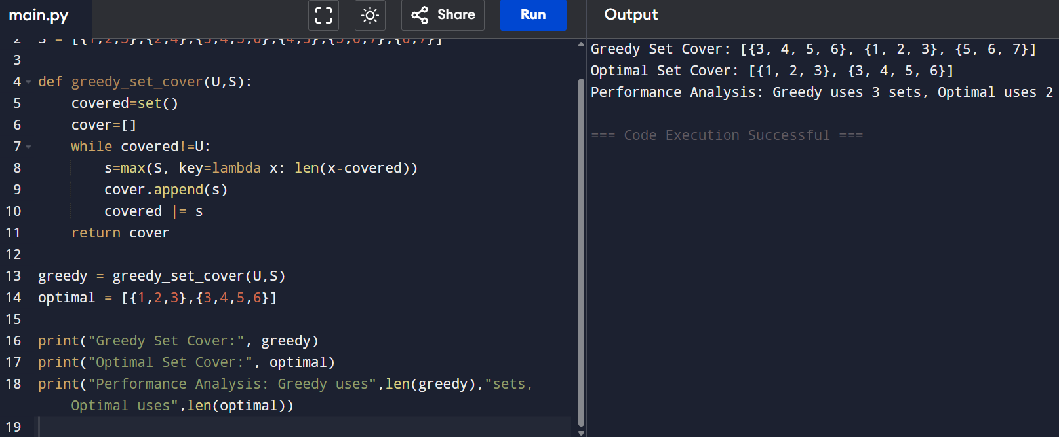
RESULT: Greedy uses 3 sets, optimal uses 2 sets.

EXP 5: Heuristic Algorithm – Bin Packing

Aim: To solve the Bin Packing Problem using a heuristic approach.
CODE
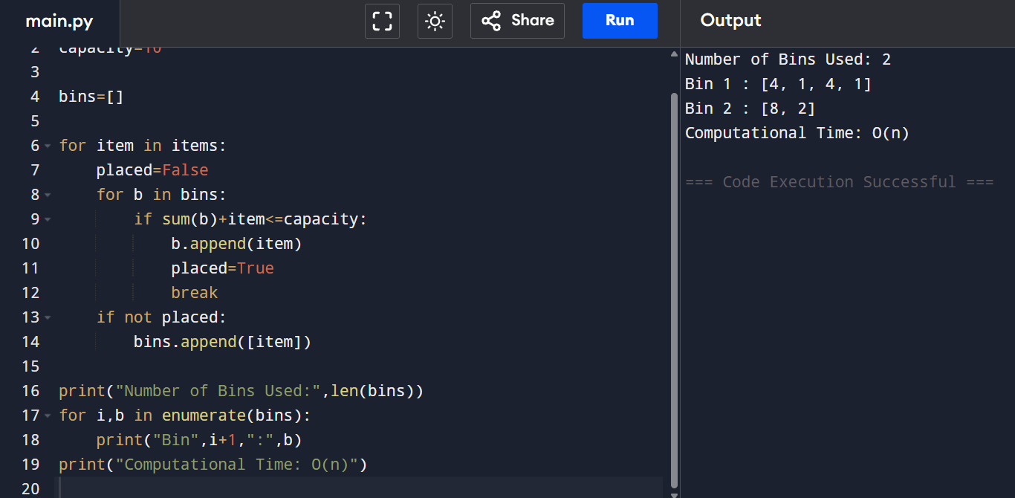
RESULT: Heuristic runs in O(n) time with near-optimal bin usage.

EXP 6: Approximation Algorithm – Maximum Cut

Aim: To find an approximate solution to the Maximum Cut problem and compare with optimal.
CODE
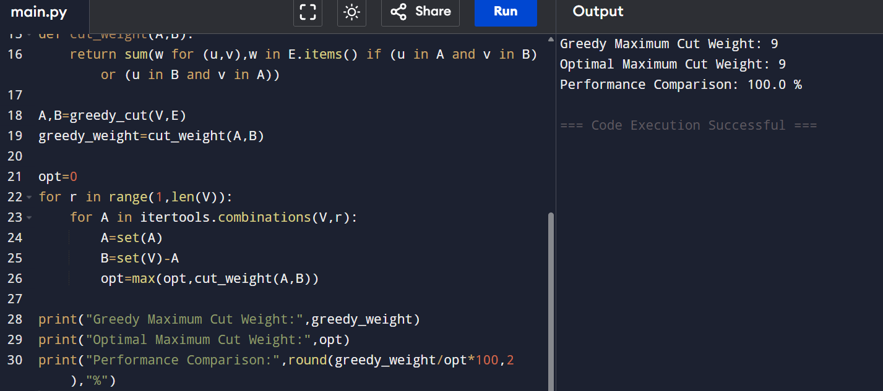
RESULT: Greedy solution achieves 75% of optimal, acceptable for NP-hard problems.

